LOUISIANA RICE PROMOTION BOARD (LARPB)
Meeting Minutes
LSU AgCenter, Rice Research Station
Crowley, LA

Thursday, June 28, 2012

A meeting of the Louisiana Rice Promotion Board was held on June 30, 2011, 2010 at the LSU Rice Research Station.

Officers and Members Present: Kevin Berken, Wayne Zaunbrecher, Jimmy Hoppe, Christian Richard, Damian Bollich, Ronald Habetz, Mindy Hetzel and Mike Strain

Officers and Members Not Present: Jeff Durand, Robert Thevis.

Staff Present: Mary Baronet. Nicole Broussard, Scott Privat, and Carrie Castile.

Staff Not Present: Julie Richard

Others Present: Randy Jemison, Jim Guinn, Anne Banville, and Carl Krielow, and
Call to order, certification of a quorum, agenda review, approval of Wednesday, December 14, 2011 minutes and opening comments.

Chairman Berken called the LARPB meeting to order at 12:45 p.m. and welcomed members and guests. Roll was called and Chairman Berken certified that a quorum was present and presented the agenda for consideration.

The following additions were made in the agenda:
Set an annual deadline for funding requests to be submitted to the Board
Addition of travel funds to the budget

MOTION by Jimmy Hoppe; Second by Christian Richard

To accept the agenda as amended.

MOTION CARRIED UNANIMOUSLY

MOTION by Jimmy Hoppe; Second by Christian Richard

To accept the minutes of the December 14, 2011 meeting as submitted.

MOTION CARRIED UNANIMOUSLY
Chairman Berken reminded that board that the promotion and research boards were obvious targets of a law suit filed against the Louisiana Department of Agriculture and Forestry. He stressed the need for the two boards to discuss the litigation and indicated he would entertain a motion to do so in executive session. Berken noted that the open meetings law does allow the board to meet in executive session to discuss litigation and that legal council could participate in the Session.

MOTION by Jimmy Hoppe and Second by Christian Richard

For the board members to go into an executive session.

MOTION CARRIED UNANIMOUSLY

At approximately 1:50 p.m., Berken asked for a motion to continue the regular session.

MOTION was made by Jimmy Hoppe and Second by Wayne Zaunbrecher.

MOTION CARRIED UNANIMOUSLY

Referendum 2012

Chairman Berken provided the board with copies of the referendum vote tally sheet, which had also been provided to them in immediately after the vote and noted that the promotion program was renewed by 75% of the voters.

MOTION by Jimmy Hoppe and Second by Damian Bollich.

To ratify the 2012 Louisiana Rice Promotion Referendum voting results as presented.

MOTION CARRIED UNANIMOUSLY

In-State Promotion and USA Rice Council Project Reports and Funding Requests
Documentation on the update of the in-state promotion projects was included in member meeting packets. The below were highlighted:
2011-112 In-state Promotions Budget Status as of June 8, 2012 |  |  |  | Projected Costs  2012-13
Event/Activity | Budget | Expenditures | Variance
LA Rice- Awesome Education Project | $5,500 | $5,320 | ($180) | $5,500
AgMagic | $1,000 | -0- | ($1,000) | $1,000
LAFB Cooking Segment | $5,000 | -0- | ($5,000) | $5,000
NRM 5-K Rice Run | $1,200 | $1,200 | -0- | $1,200
NRM Radio Campaign | $5,000 | $4,995 | $5 | $5,000
Yellow Rails & Rice Festival | $500 | $500 | -0- | $500
Legislator/Public Education | $1,000 | -0- | ($1,000) | $1,000
Total | $19,200 | $12,015 | $7,185* | $19,200
*As of 6/8/12 the board has spent $7,185 less than budgeted.
Jennifer Marsh with the Louisiana Network was on hand to share results of the radio campaign to be aired in September.

Chairman Berken directed the board to the USA Rice Council funding request that had been provided with their advance meeting materials and at the meeting He then called on USA Rice Federation staff: including Randy Jemison, director of Louisiana Field Services; Jim Guinn, vice-president of international promotion and Anne Banville, vice-president of domestic promotion, to give an update on the status of USA Rice Council financials and promotion activities that were funded with Louisiana rice promotion assessments. USA Rice staff thanked the board for the opportunity to report and urged them to renew their promotion funding with the USA Rice Council

MOTION made by Mindy Hetzel and Second by Jimmy Hoppe

To accept proposed 2012-13 funding requests outlined above as presented.

MOTION CARRIED UNANIMOUSLY

Financial Reports

Nicole Broussard, CPA with Broadhurst, Hamilton & Co., rendered the LARPB financial report noting that assessments for the year ending June 30, 2012 totaled $846,659 as compared to $1,003,614 for the year ending June 30, 2011. Broussard noted that expenses for the year ending June 30, 2012 totaled $846,764, which included payments to the USA Rice Council of $787,000. She provided the current financial report to members present and reported a current cash balance of $40,566. There was a change in net assets of -$105.

MOTION by Christian Richard, Second by jimmy Hoppe

To accept the 2011-12 financials and amended budget as presented by Broussard.

MOTION CARRIED UNANIMOUSLY

Chairman Berken submitted travel expenditures and asked the board to amend the current 2011-12 budget to allow for reimbursement.

MOTION by Wayne Zaunbrecher; Second by Mindy Hetzel.

To allow travel expenditures to be reimbursed to Berken with 2011-12 funds.

MOTION CARRIED UNANIMOUSLY
Amended budget included on next page, Page 4.
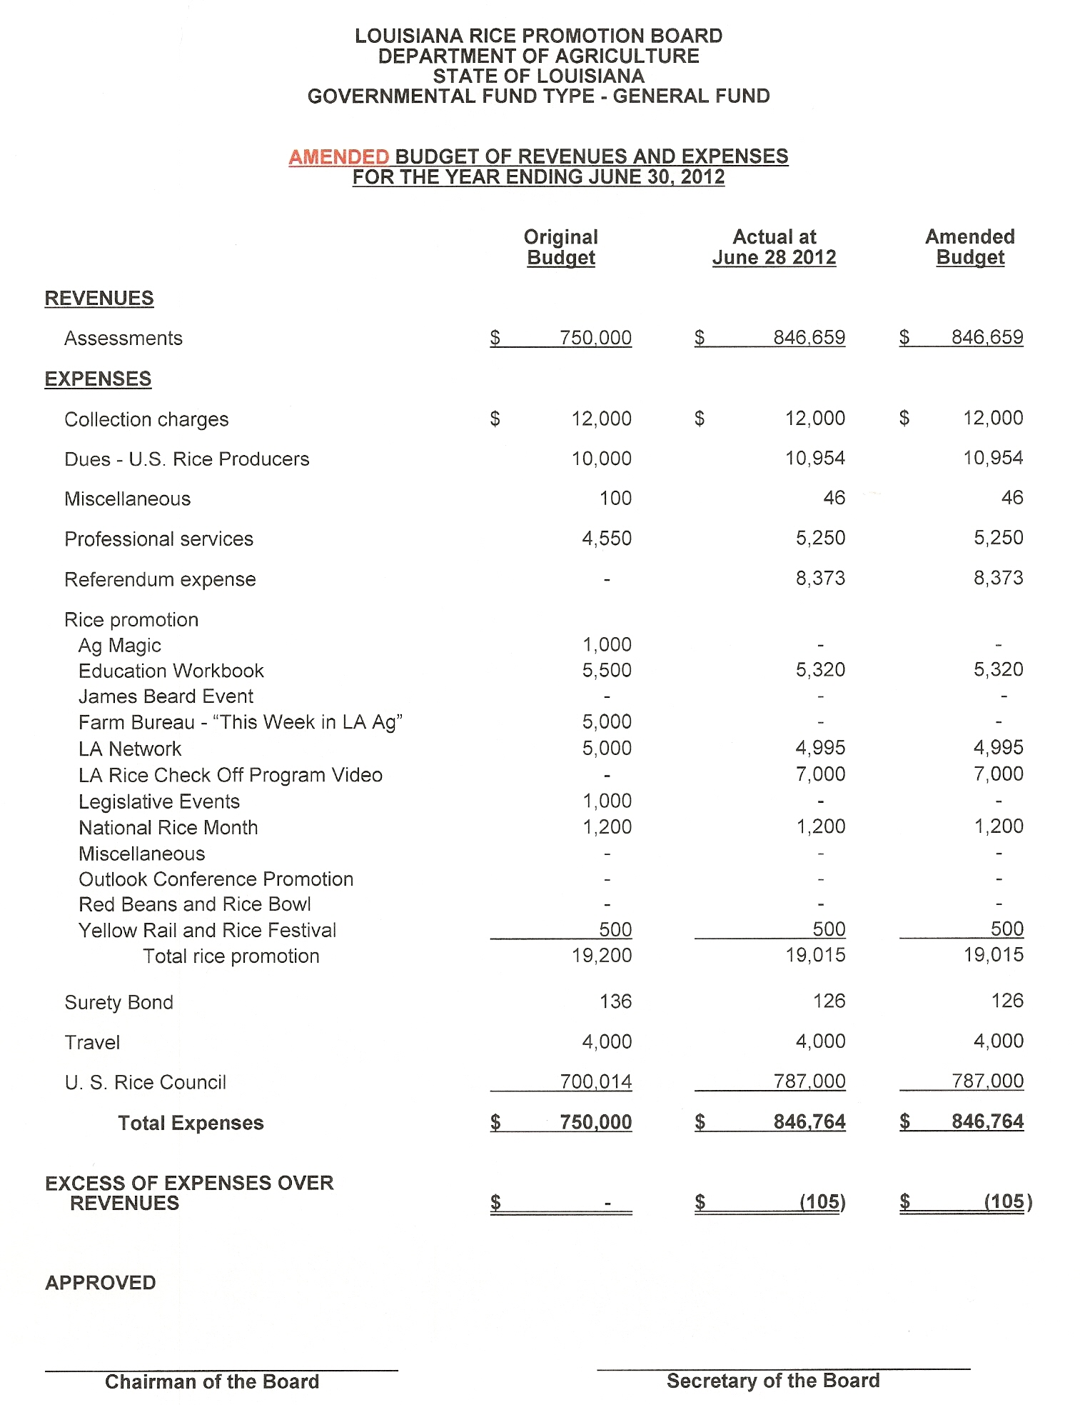

Action on 2012-2013 Contracts

Scott Privat presented the contracts between the LARPB and Broadhurst, Hamilton & Co., Privat & Privat, USA Rice Council, and USA Rice Producer’s Group. Privat reported that all contracts were to stay the same as previous contracts.

2012-2013 contract with Broadhurst, Hamilton & Co. for an annual payment of $2000
2012-2013 legal counsel annual contract with Privat & Privat for $1000
2012-2013 contract with USA Rice Producers Group that includes annual fees not to exceed $20,000.
2012-2013 contract with the USA Rice Council that includes payment limits of not less than $400,000
or more than $1,000,000.

MOTION made by Wayne Zaunbrecher, Second by Christian Richard

To renew all contracts as presented

MOTION UNANIMOUSLY CARRIED

Develop 2012-13 Budget

The board entered into a discussion of expected planted acreage and yields for the 2012-2013 rice crop and agreed to develop the 2012-2013 budget based on an estimated 400,000 planted acres yielding approximately 6750 pounds per acre. The board discussed line items to set a balanced budget for the 2012-13 fiscal year. Berken requested an annual administrative amount of $2500 be included for travel expenditures. The board then proposed the following budget.

MOTION by jimmy Hoppe, Second by Mindy Hetzel

To accept 2012-13 LARBP Budget as developed.

MOTION CARRIED.

2012-2013 Budget on next page, page 6.

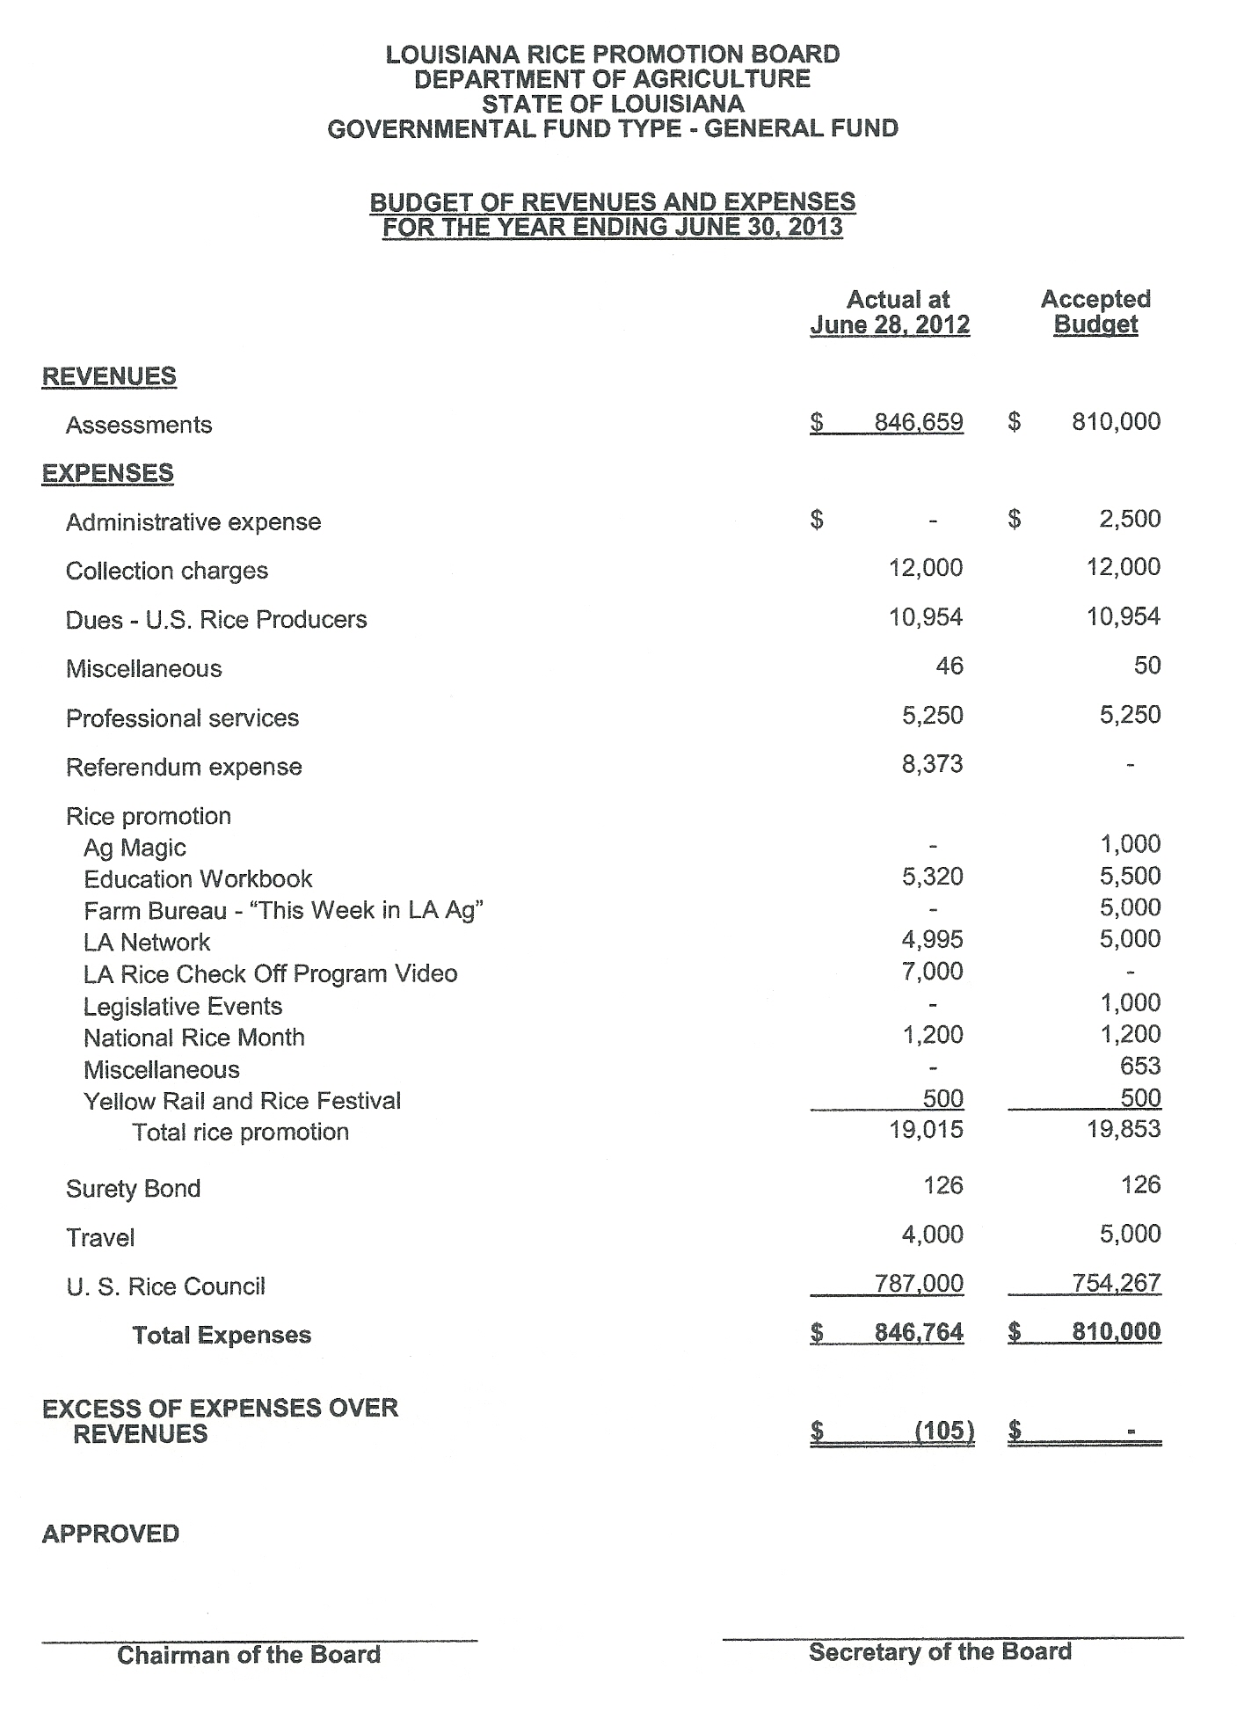
Election of Officers, LA Rice Producers’ Group Representative, and Education Liaison on Ethics

The slate of current officers, Kevin Berken, Chairman; Christian Richard, Vice Chairman and Wayne Zaunbrecher, Secretary was presented.

MOTION by Damian Bollich, Second by Jimmy Hoppe

To reelect by acclamation the full slate of officers for the 2012-13 year.

MOTION CARRIED UNANIMOUSLY

Appointment of Education Liaison on Ethics

MOTION made by Jimmy Hoppe, Second by Damian Bollich

To reappoint Scott Privat as LA Ethics Commission liaison for the LA Rice Promotion Board.

MOTION CARRIED UNANIMOUSLY

Appointment of LARPB Representative to LARPG

MOTION by Jimmy Hoppe, Second by Wayne Zaunbrecher

To appoint Jeff Durand as LARPB Representative to LA Rice Producers’ Group

MOTION CARRIED UNANIMOUSLY

Public comments

Chairman Berken asked if there were any public comments. None were offered.

Adjournment

MOTION by Ronald Habetz, Second by Wayne Zaunbrecher

To adjourn at 3:32 p.m.

MOTION CARRIED UNANIMOUSLY.

